Implement and Test EDF Scheduler

The System Consists of 6 Tasks Tasks Properties :

Task 1:

Period = 50 ms

Deadline = 50 ms

Priority = Dynamic

Execution Time = 1.8 ms

Task 2:

Period = 50 ms

Deadline = 50 ms

Priority = Dynamic

Execution Time = 2.6 ms

Task 3:

Period = 100 ms

Deadline = 100 ms

Priority = Dynamic

Execution Time = 3 ms

Task 4:

Period = 20 ms

Deadline = 20 ms

Priority = Dynamic

Execution Time = 1.6 ms

Task 5:

Period = 10 ms

Deadline = 10 ms

Priority = Dynamic

Execution Time = 5 ms

Task 6:

Period = 10 0ms

Deadline = 100 ms

Priority = Dynamic

Execution Time = 12 ms

* The hyperperiod=100 ms The highest periodicity of all tasks
* CPU load



( U ) = $\frac{1.8}{50}+\frac{2.6}{50}+\frac{3}{100}+\frac{1.6}{20}+\frac{4.8}{10}+\frac{12}{100}=72.8$

* system schedulability using URM and time demand analysis

U=72.8

URM=6((2^1/6) – 1) =73.4

URM>U

So the system in schedulable

Time demand analysis

All tasks are schedulable

Because their execution time is small compared to the periodicity and deadline so there is no task will miss deadline

Calculate time demand analysis for task 6 which is the highest priority task

W(1)=12+0=12

W(2)=12+0=12

W(3)=12+0=12

W(4)=12+0=12

W(5)=12+0=12

W(6)=12+0=12

W(7)=12+0=12

W(8)=12+0=12

W(10)=12+0=12

.

..

…

..

W(100)=12+0=12

12<50 task is schedulable

Calculate time demand analysis for task 5

W(1)=5+(1/50)\*12=5.24

W(2)= 5+(2/50)\*12=5.1

..

W(10)= 5+(10/50)\*12=7.4

7.4<10 task is schedulable

Calculate time demand analysis for task 4 which is the highest priority task

W(11)=1.6+(11/50)\*12+(11/10)\*5=9.74

..

…

..

W(20)= 1.6+(20/50)\*12+(20/10)\*5=16.4

16.4<20 task is schedulable

Calculate time demand analysis for task 3 which is the highest priority task

W(21)= 3+(21/20)\*1.6+(21/50)\*12+(21/10)\*5=19.48

.

..

…

W(100)= 3+(100/20)\*1.6+(100/50)\*12+(100/10)\*5=85

85<100 task is schedulable

Calculate time demand analysis for task 2 which is the highest priority task

W(1)= 2.6+(1/50)\*3+(21/20)\*1.6+(21/50)\*12+(21/10)\*5=19.88

.

..

…

..

W(50)= 2.6+(50/50)\*3+(50/20)\*1.6+(50/50)\*12+(50/10)\*5=46.6

task is schedulable

Calculate time demand analysis for task 1 which is the highest priority task

W(1)=1.8+ (1/50)\*2.6+(1/50)\*3+(21/20)\*1.6+(21/50)\*12+(21/10)\*5=

.

..

…

..

W(50)= W(1)=1.8+ (1/50)\*2.6+(1/50)\*3+(21/20)\*1.6+(21/50)\*12+(21/10)\*5=48.4

task schedulable

* 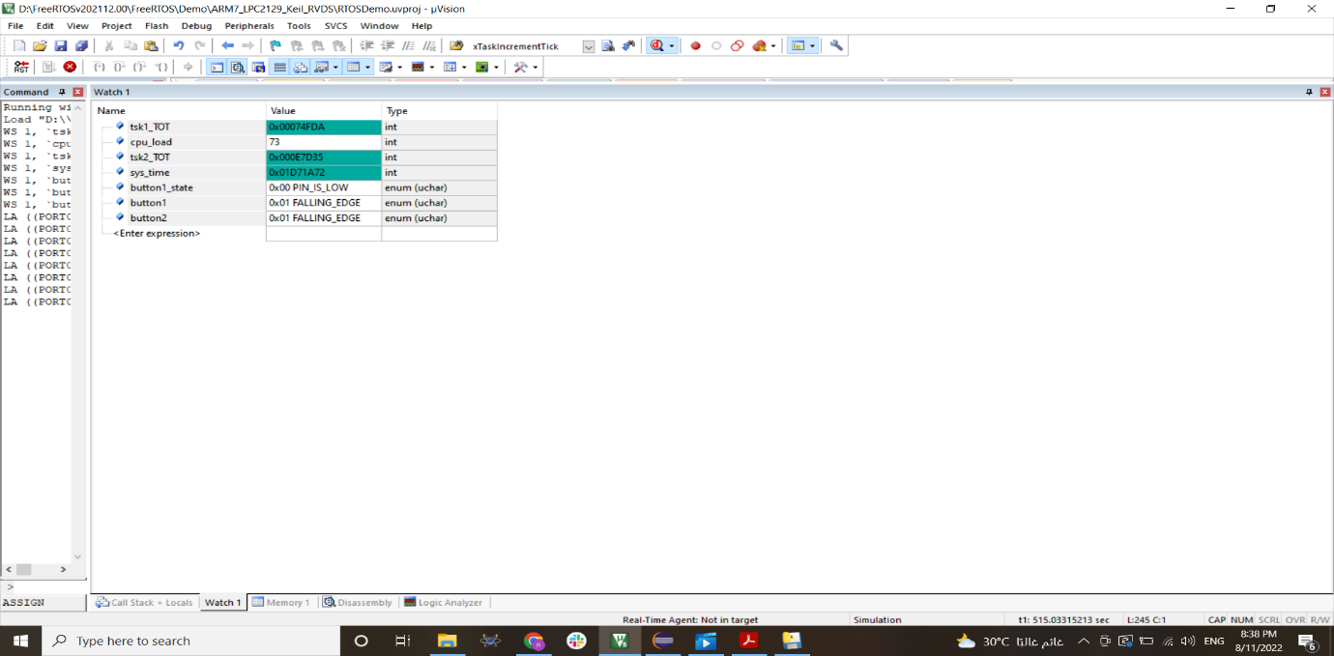cpu load from keil

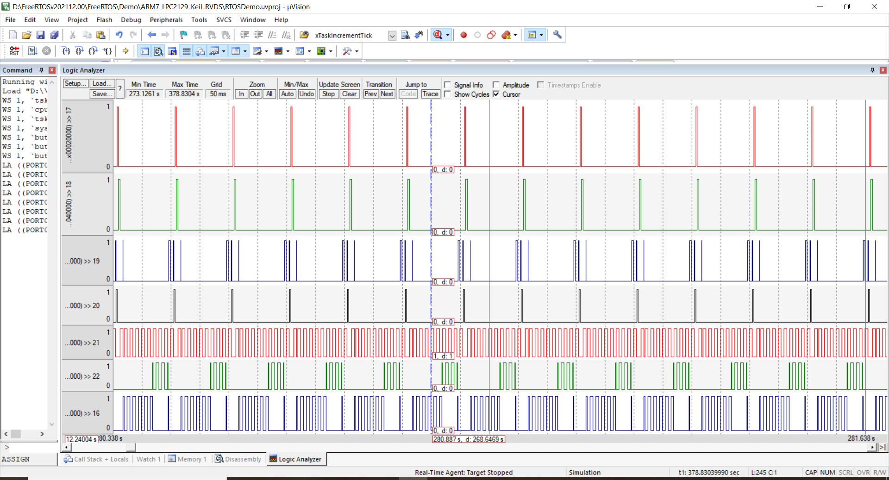

* tracing of execution time from keil

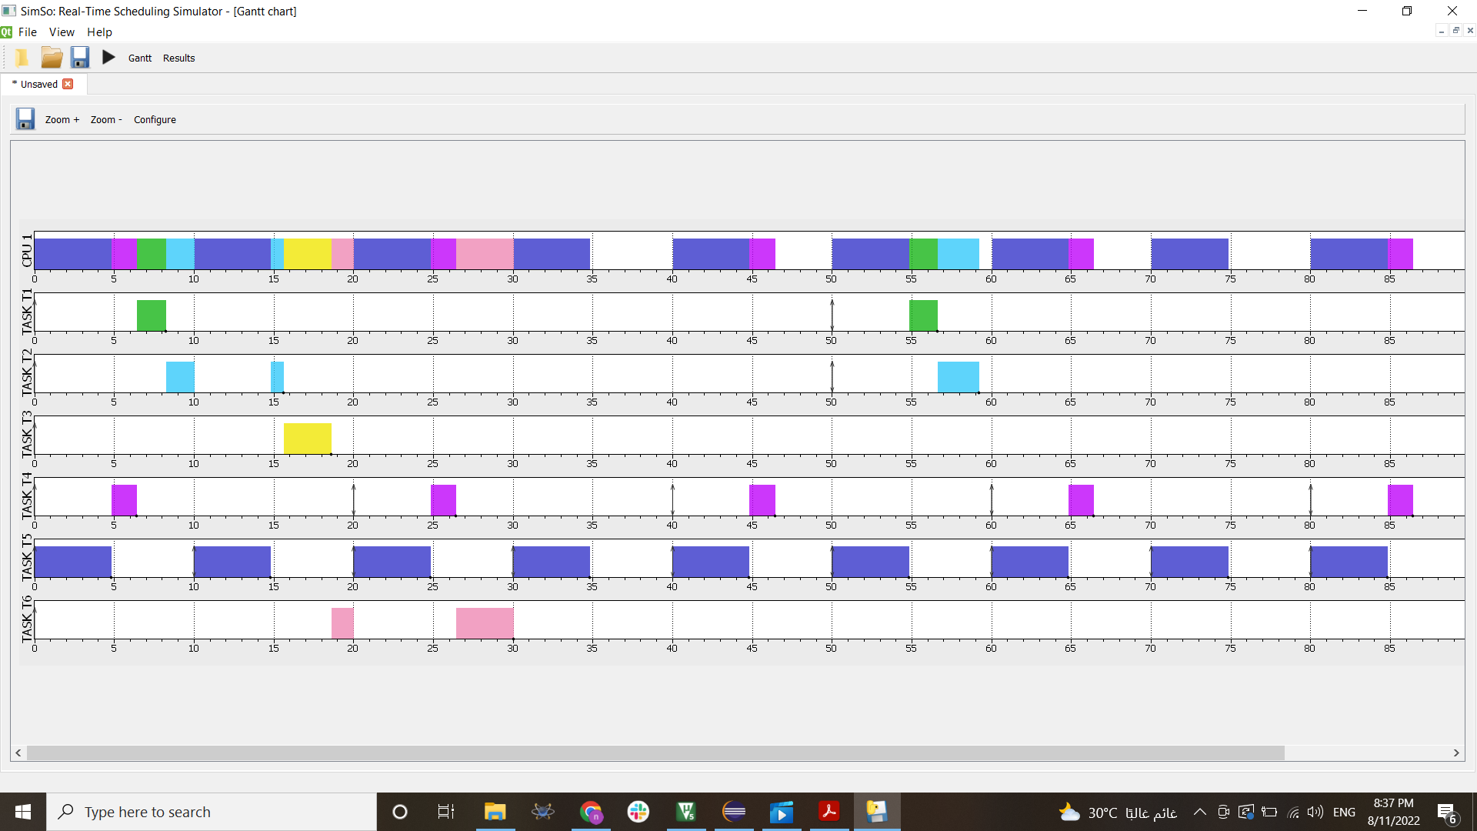

* GANTT chart at simso
* 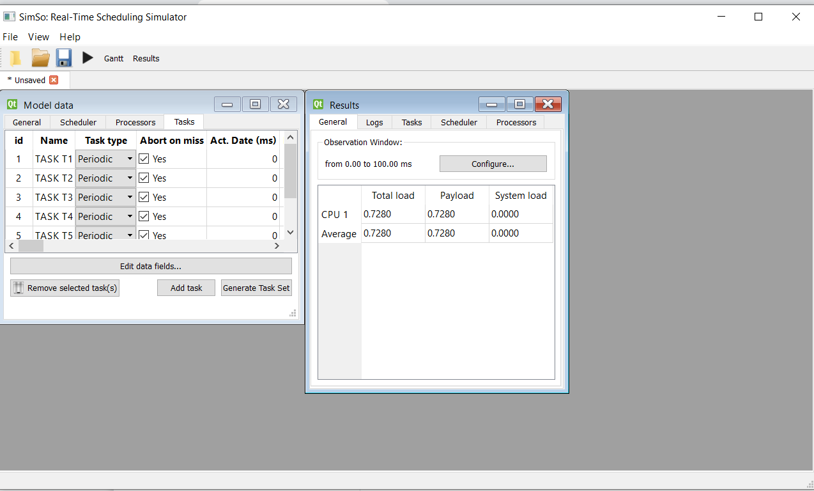CPU load at simso

Are the results as expected ?

The result as I expected

Does the results indicate a successful implementation ?

Yes cause the analysis is equal the values from simulator